**Developer Diary**

# Introduction

This Developer Diary is a requirement for a 4th Year software development module, Mobile Applications Development 3. Within this diary I will keep account of the thought process and weekly development of the game.

# Entry 1. 28/09/18

By reading the design document that was provided by the customer I could see that he was looking for me to develop a platformer game. His main concept idea is you move an avatar through an ever changing world and along the way you will have to jump over obstacles, defeat enemies and collect bonuses. The overall aim is to collect as many of these bonuses along the way to the finish line.

Key points about the game:

1. Platformer
   * Marathon
   * Ever-changing world
2. Objects
   * Coins
   * Positive Objects
   * Negative Objects
3. Character
   * Has health
4. Front End
   * Start menu
   * Pause menu
   * End Menu

Issues to flag with customer

* Controllers
* Layout
* Enemies?
* Scoring
* Social media

# Entre 2. 01/10/18

Here I have included a mind map that I created to try and understand the game which I am developing

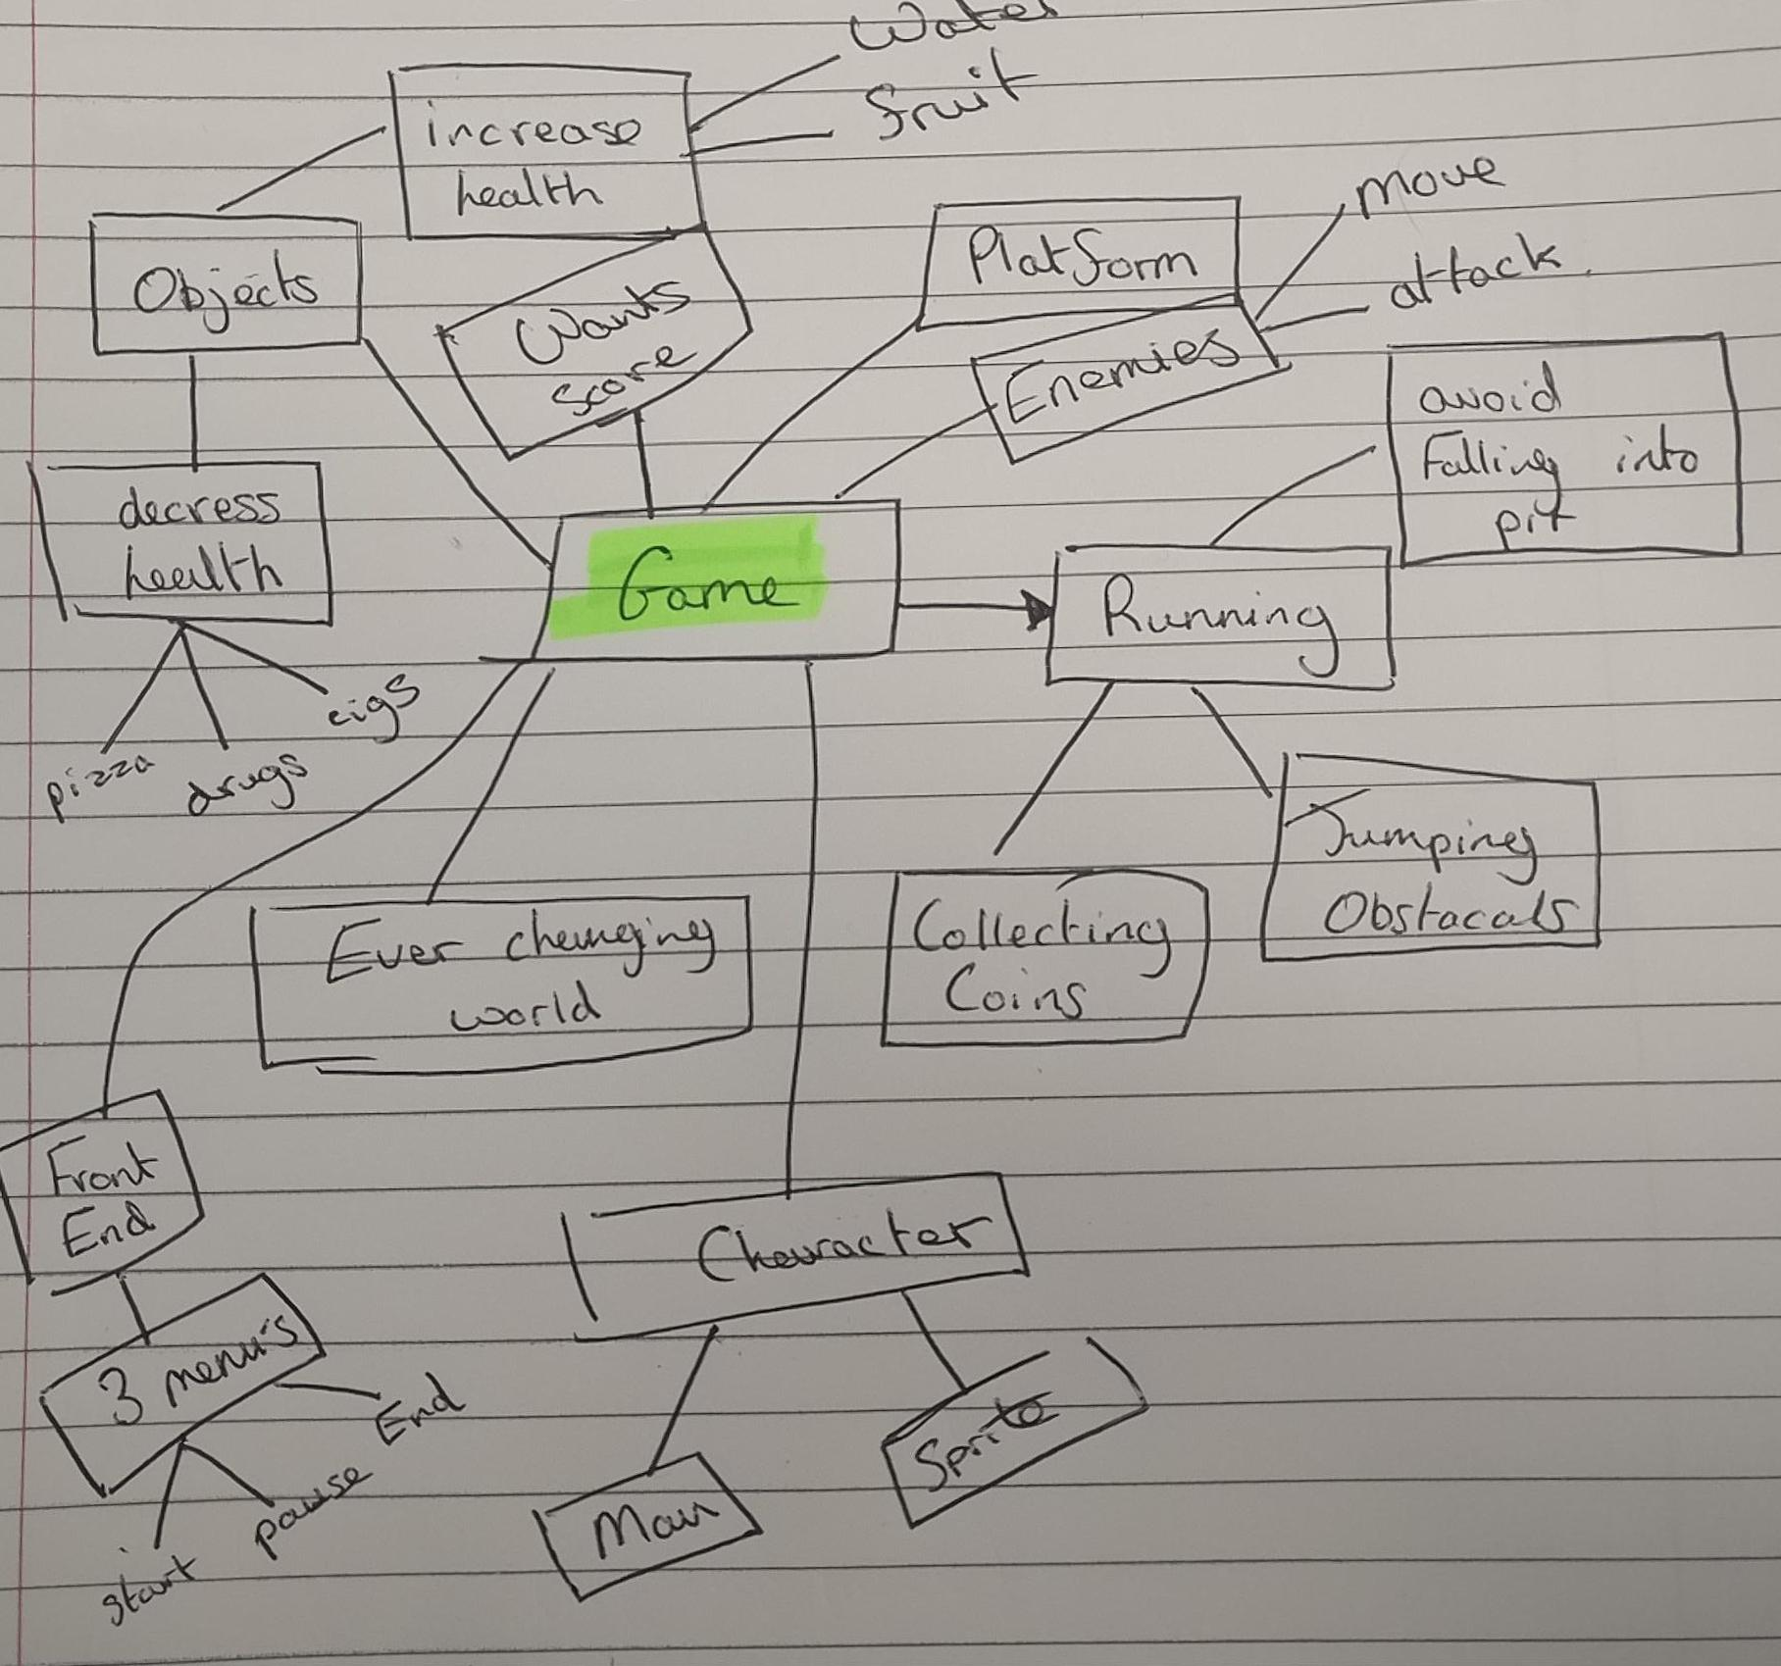

# Entre 3. 07/10/18

Completed another day of research into how the game was going to be developed. I searched the Asset store for potential sprites and tiles that could be used within the game. At the moment I am not sure what we can and can’t use from the asset store. This will need to be cleared up with the lecturer.

To get things rolling I created a new project within Unity and linked that project my GitHub

# Entre 4. 09/10/18

I started development by creating a character within Unity. I felt it was the best approach to create a character, get him to move and then work onto the rest of the game like platforms etc. As I am new to Unity I looked for online tutorials on how to help create a 2D Unity game. Unity itself provides great documentation which I used help get my character moving. At the moment I am just focusing on getting the game working with the pc keyboard. I will change that to touch screen inputs at a later point.

# Entre 5.

# Entre 6.

# Entre 7.

# Entre 8.

# Entre 9.

# Entre 10.